Elle Chaska - Full Bio
https://www.ellechaska.com

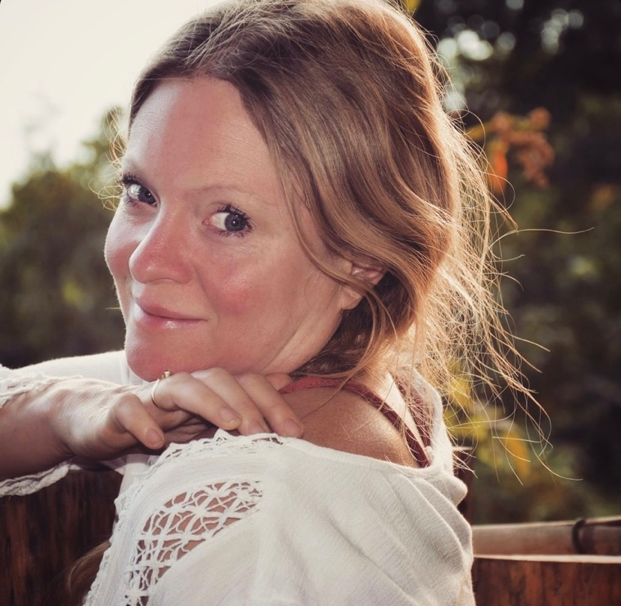

Elle is a modern day herbalist whose music is inspired by the natural world that she works with. Her songs of reverence for the natural world are a way of giving back to the plants which help to shine a light on the pathways of so many people’s personal transformation journey.
Based on an organic herb farm in Somerset, she creates music whilst surrounded by the plants she loves and works with, many of her songs have a strong ecological message and a call to take greater care of the planet.
She has been playing the guitar since she was 14 but didn’t start recording music until her 40’s, after many years of being a herbalist, foraging teacher, ceremonialist and a home educating mother - it was only as her child grew older that space appeared to start taking her lifelong passion of playing music to the next level.
She grew up in a household that loved Jazz and you can hear some of that influence in her occasional progressive chord choices. She is Celtic in her bloodline with both Scottish and Irish ancestry and her folk sounds are very influenced by these cultures.
She spent her youth in London and loved to dance to Drum and Bass and so some dance influences also creep into some of her songs. As each song is often a depiction of a plant in musical form she has been very open to using a mixture of musical styles in her songs, there is a definitive diversity to her musical style whilst still maintaining to weave in the threads of her own personal style. She also brings a lot of humour thorough song and reminders to not take ourselves too seriously.

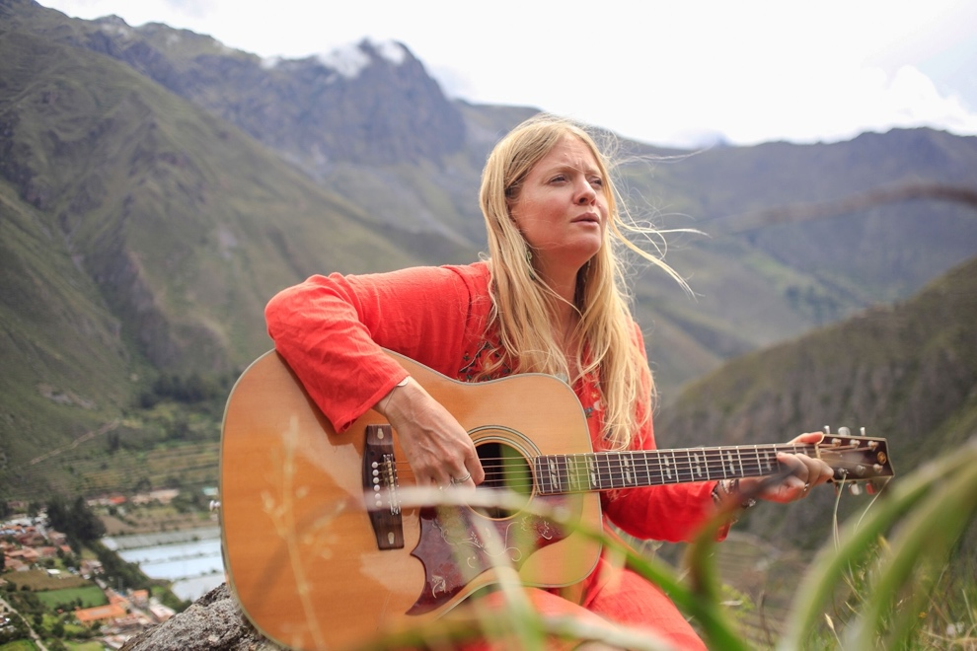

Her first album was engineered by Tristan Starling at Chaski Records based in Stroud. ‘Earthwise’ follows the journey through life from being born to discovering wonders of the natural world around us and to its natural conclusion of transitioning back to spirit.
Before recording her album Elle played live in circles for many years at herbal tea ceremonies, conscious events etc and in the last three years since becoming a recording artist she has played live at many events. She is a regular feature at Milverton Folk Music Club and has played at UK festivals including appearances at, The Mind, Body, Spirit Festival at the NEC (2023), Buddahfield Festival (2023), Kernow Healing Fields Festival (2024), Campfire Convention (2024), and Medicine Woman Festival (2024) – you can see her live performance at Medicine Woman here on YouTube. https://youtu.be/Arb1JlM7bCI
Her song Amanita Rise is also due to feature in an upcoming documentary about healing mushrooms being created in the USA. Whilst on YouTube her song about connecting to your inner child went viral with over 40K views and counting as people loved connecting to the joy and innocence of the song.
She has collaborated on her album with many notable musicians including Asha McCarthy who has also played Cello for Beyonce, and Iam13E a Bristol Based Rapper who recently won the 2024 Rum Shack MC competition, landing him a place on stage at Glastonbury Festival.
Her album is available to stream and purchase on Bandcamp: https://ellechaska.bandcamp.com

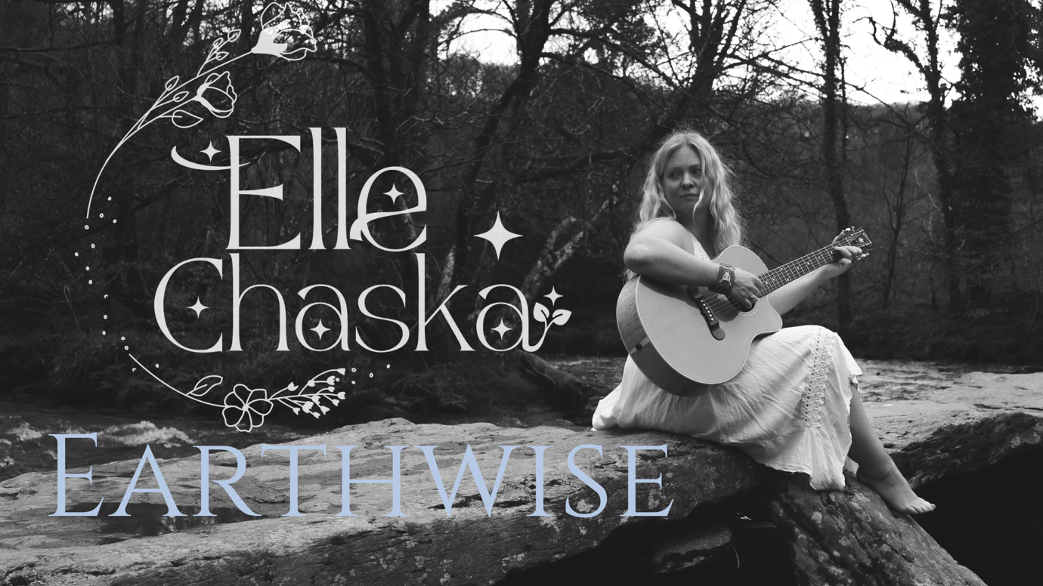

Upcoming Events (highlights): 2025

Rainbow Woods, Devon –5th April Album Launch Concert
Paradis Festival, Cornwall, 4-6th July
All Things Fungi Festival, Sussex – 12-14th September
Visit https://www.ellechaska.com/event-list for the latest gigs and events.

Videos:
This video shows some of the process of the album being made https://youtu.be/iPoYkg7gAsc
This video shows a live performance at Medicine Woman Festival
https://youtu.be/Arb1JlM7bCI

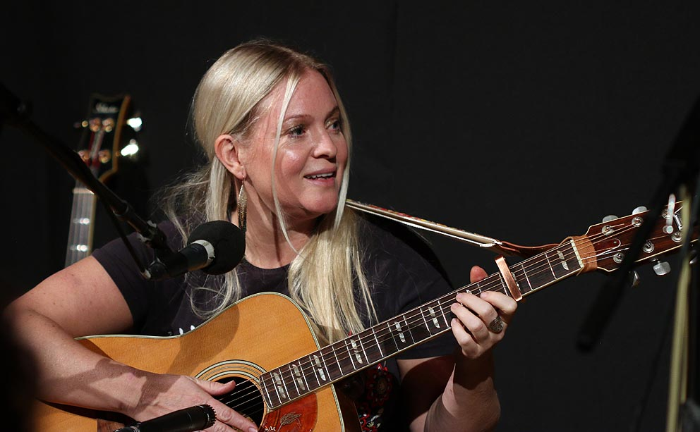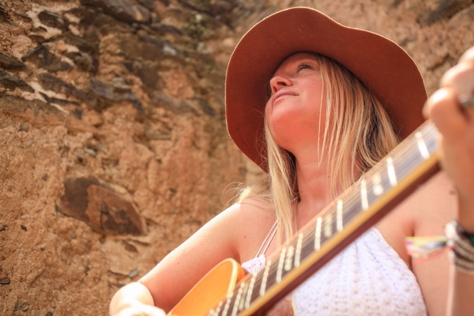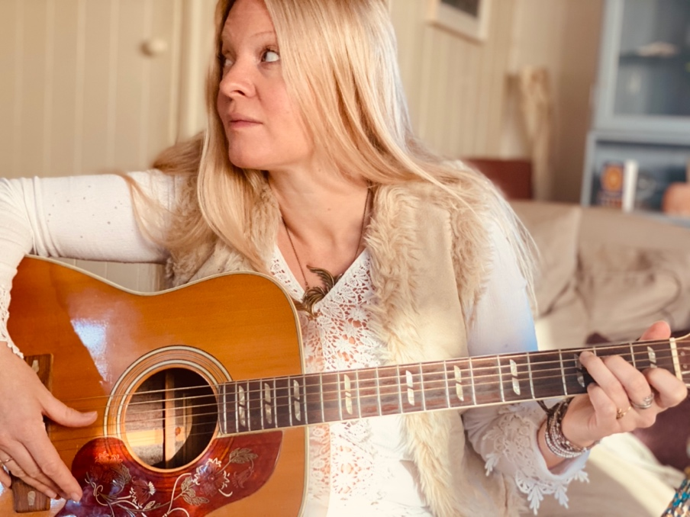

Contact Details:
https://www.ellechaska.com/contact
+44 (0) 7966 343287 eleanorchaska@fastmail.fm

